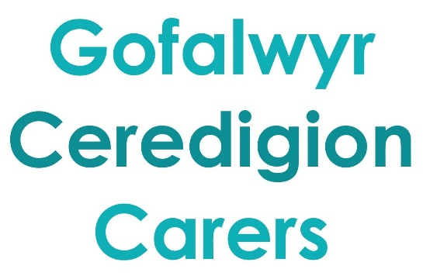

Young Carers Outreach Workers
2 Posts covering North Ceredigion or South Ceredigion

SALARY: £21,600-£23,410 per annum pro rata (salary scale currently under review)
HOURS: 21 per week
LENGTH OF CONTRACT: Funded till 31st March 2024
LOCATION: Working from home with travel

This is an exciting opportunity to be part of a movement that facilitates and enables Young Carers to enjoy a greater sense of wellbeing and better life chances.

We are looking for a special person who has energy and passion as well as the self-awareness and skills to support young people and families in a way that is relational, enabling and empowering? The post holder will:

- Listen to Young Carers to get to the heart of what matters most to them, to understand their priority outcomes
- Develop bespoke support that may include a one to one work with individuals and in some cases, their family too.
- Support Young Carers and their families to build connections in a range of different ways including organising:
- Young Carers groups (face to face and ‘on-line’)
- Trips and experiences
- Mentoring links
- Raise awareness and recognition with Young Carers in schools and communities
- Support Young Carers to have a voice and influence on what matters most to them both individually and collectively.
- Collaborate effectively with volunteer and paid colleagues as well as with other organisations.

This post requires an enhanced DBS check with a children's barred list check.

You can read the job description, person specification and application form at:

https://www.carers.cymru/ceredigiongetinvolved

or call 03330 143377

Deadline for applications is 9am on 31/03/22 to hr@credu.cymru Interviews scheduled to take place 05/04/2022 via Zoom.

