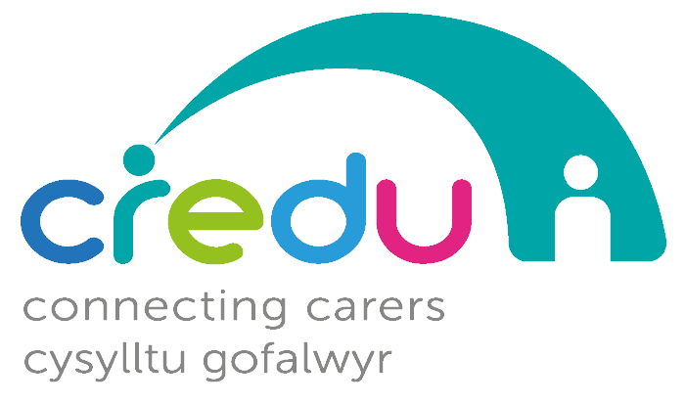

Administration Support
SALARY: £18,525 - £21,600* per annum pro rata
(*dependent on individual’s skills)
HOURS: 24 per week available (flexible)
HOLIDAY ENTITLEMENT: 27 days (pro rata) plus statutory bank holidays
PENSION: 3%
LENGTH OF CONTRACT: Until 31st March 2022
BASED AT: Llandrindod Wells Office

- Are you passionate about people and giving every person an excellent experience of support?
- Do you have an eye for detail and love getting things done to a high standard?
- Do you have experience of administration?
- Are you able to deal with multiple tasks and prioritise workloads effectively?

If you answered yes to the above, then you have an exciting opportunity to work within our passionate and committed Central Support team and be:

- An efficient and effective source of administration support.
- An excellent first point of contact with Credu for Carers and others.

Credu’s purpose is to empower all young and adult Carers to enjoy a good quality of life and sense of wellbeing.
We are a charity which gives enabling, person-centered support to Young Carers and Adult Carers throughout Powys, Adult Carers in Ceredigion and Young Carers throughout Wrexham, Conwy & Denbighshire.

You can read the job description, person specification and application form at https://www.carers.cymru/credugetinvolved

Deadline for applications is 9am on Tuesday 7th December, 2021 to hr@credu.cymru

Interviews provisionally scheduled to take place in week beginning 13th December, 2021.

